**Lab Sheet 4**

[1] WAP to display protocol, authority, host, port, path, query, file name and ref from the URL "http://example.com:80/docs/books/tutorial" + "/index.html?name=networking# DOWNLOADING"

**Source code:**

**package** Lab4;

**import** java.net.MalformedURLException;

**import** java.net.URL;

**public** **class** Question1 {

**public** **static** **void** main(String[] args) {

// **TODO** Auto-generated method stub

String name = "http://example.com:80/docs/books/tutorial" +

"/index.html?name=networking#\r\n" + "DOWNLOADING";

**try** {

URL uname= **new** URL(name);

System.***out***.println("Authority"+ uname.getAuthority());

System.***out***.println("Host:"+uname.getHost());

System.***out***.println("PORT:"+uname.getPort());

System.***out***.println("Path: "+ uname.getPath());

System.***out***.println("Query: "+ uname.getQuery());

System.***out***.println("File:"+uname.getFile());

System.***out***.println("Protocol:"+uname.getProtocol());

} **catch** (MalformedURLException e) {

// **TODO** Auto-generated catch block

System.***out***.println(e.getMessage());

}

}

}

**Output:**

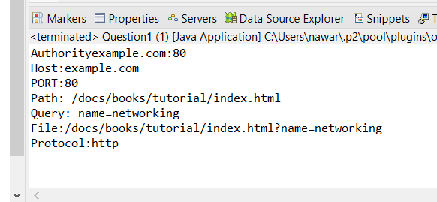

1. WAP to read directly from a URL. [HINT: you may use any URL for reference].

**Source code:**

**package** Lab4;

**import** java.io.*;

**import** java.net.URL;

**import** java.net.URLConnection;

**public** **class** Question2 {

**public** **static** **void** main(String[] args) **throws** IOException {

// **TODO** Auto-generated method stub

String urlString = "https://beta.openai.com/docs/";

URL u= **new** URL(urlString);

URLConnection con = u.openConnection();

**try** {

BufferedReader br= **new** BufferedReader(**new** InputStreamReader(con.getInputStream()));

String line;

**while** ((line = br.readLine()) != **null**) {

System.***out***.println(line);

}

} **catch** (Exception e) {

// **TODO**: handle exception

System.***out***.println(e.getMessage());

}

}

}

**Output:**

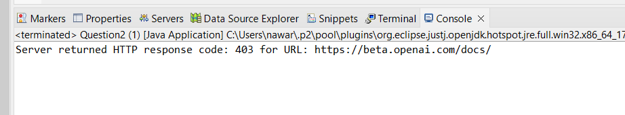

1. WAP to implement chatting programming between server and multiple clients.

**Source code:**

**package** Lab4;

**import** java.io.IOException;

**import** java.io.PrintWriter;

**import** java.net.ServerSocket;

**import** java.net.Socket;

**import** java.util.HashSet;

**import** java.util.Scanner;

**import** java.util.Set;

**public** **class** ChatServer {

**private** **static** Set<PrintWriter> *clientWriters* = **new** HashSet<>();

**public** **static** **void** main(String[] args) **throws** IOException {

**try** (ServerSocket serverSocket = **new** ServerSocket(1234)) {

System.***out***.println("Server is running and waiting for clients...");

**while** (**true**) {

Socket clientSocket = serverSocket.accept();

System.***out***.println("Client connected: " + clientSocket);

PrintWriter writer = **new** PrintWriter(clientSocket.getOutputStream(), **true**);

*clientWriters*.add(writer);

Thread clientHandler = **new** Thread(**new** ClientHandler(clientSocket, writer));

clientHandler.start();

}

}

}

**private** **static** **class** ClientHandler **implements** Runnable {

**private** Socket clientSocket;

**private** PrintWriter writer;

**public** ClientHandler(Socket clientSocket, PrintWriter writer) {

**this**.clientSocket = clientSocket;

**this**.writer = writer;

}

@Override

**public** **void** run() {

**try** (Scanner scanner = **new** Scanner(clientSocket.getInputStream())) {

**while** (scanner.hasNextLine()) {

String message = scanner.nextLine();

*broadcast*(message);

}

} **catch** (IOException e) {

System.***out***.println("Error handling client: " + e.getMessage());

} **finally** {

**if** (writer != **null**) {

*clientWriters*.remove(writer);

}

}

}

}

**private** **static** **void** broadcast(String message) {

**for** (PrintWriter writer : *clientWriters*) {

writer.println(message);

}

}

}

**package** Lab4;

**import** java.io.IOException;

**import** java.io.PrintWriter;

**import** java.net.Socket;

**import** java.util.Scanner;

**public** **class** ChatClient {

**public** **static** **void** main(String[] args) **throws** IOException {

**try** (Socket socket = **new** Socket("localhost", 1234);

PrintWriter out = **new** PrintWriter(socket.getOutputStream(), **true**);

Scanner in = **new** Scanner(socket.getInputStream());

Scanner scanner = **new** Scanner(System.***in***)) {

Thread receiveThread = **new** Thread(() -> {

**while** (in.hasNextLine()) {

System.***out***.println("Server: " + in.nextLine());

}

});

receiveThread.start();

System.***out***.println("Enter your name:");

String name = scanner.nextLine();

out.println(name + " has joined the chat.");

System.***out***.println("Start typing your messages (Type 'exit' to leave):");

**while** (**true**) {

String message = scanner.nextLine();

**if** ("exit".equalsIgnoreCase(message)) {

**break**;

}

out.println(name + ": " + message);

}

}

}

}

**Output:**

